ANGULAR HANDS ON 5
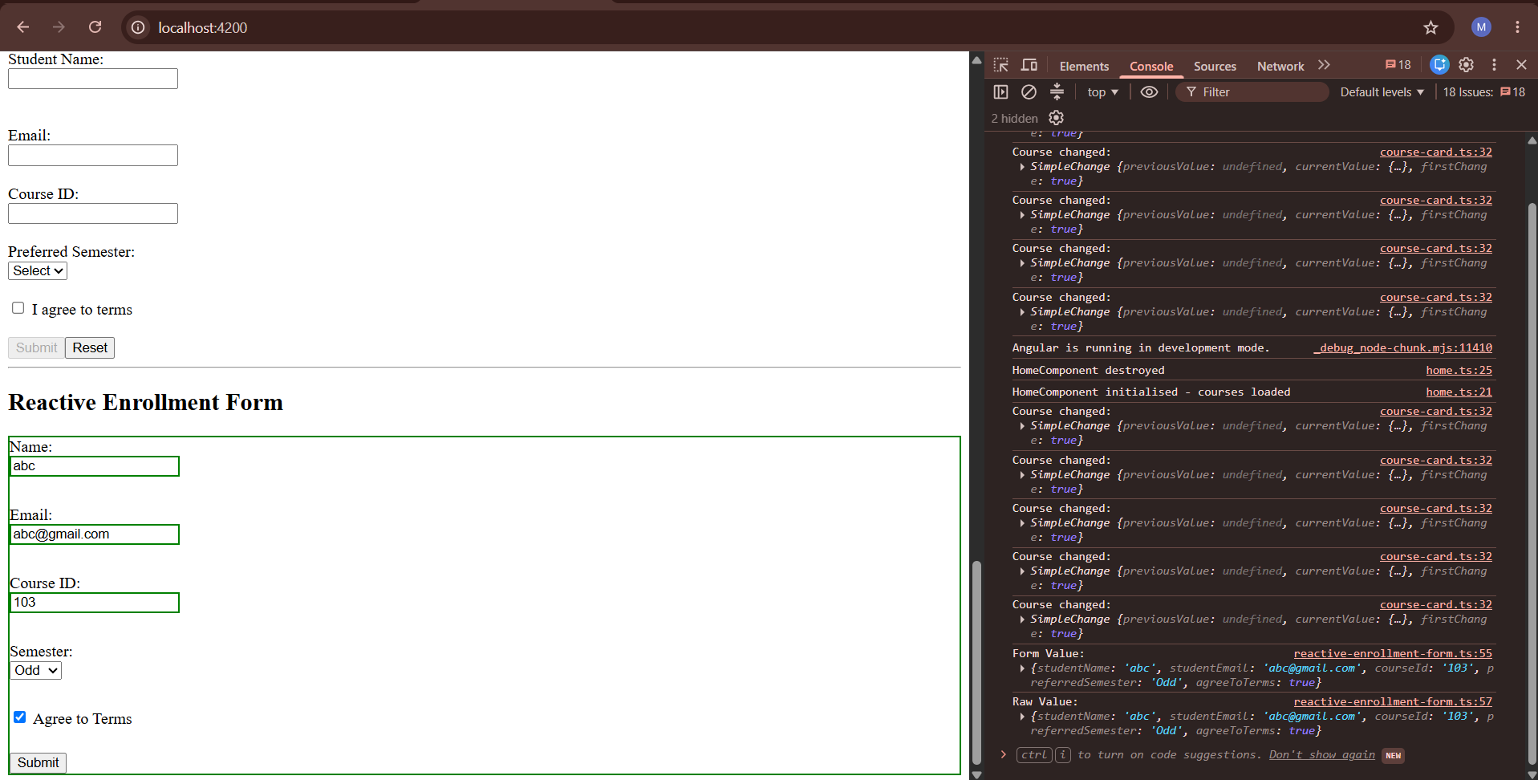
Reactive enrolment form.ts

import { Component } from '@angular/core';
import {
ReactiveFormsModule,
FormBuilder,
FormGroup,
Validators,
AbstractControl,
ValidationErrors,
FormArray,
FormControl
} from '@angular/forms';

import { CommonModule } from '@angular/common';

@Component({
selector: 'app-reactive-enrollment-form',
imports: [CommonModule, ReactiveFormsModule],
templateUrl: './reactive-enrollment-form.html',
styleUrl: './reactive-enrollment-form.css'
})
export class ReactiveEnrollmentForm {

enrollForm: FormGroup;

constructor(private fb: FormBuilder) {

this.enrollForm = this.fb.group({

studentName: [
'',
[Validators.required, Validators.minLength(3)]
],

studentEmail: [
'',
[Validators.required, Validators.email],
[this.simulateEmailCheck]
],

courseId: [
'',
[Validators.required, this.noCourseCode]
],

preferredSemester: [
'Odd',
Validators.required
],

agreeToTerms: [
false,
Validators.requiredTrue
],

additionalCourses: this.fb.array([])

});

}

onSubmit() {

console.log('Form Value:', this.enrollForm.value);

console.log(
'Raw Value:',
this.enrollForm.getRawValue()
);

}

// Custom Validator
noCourseCode(control: AbstractControl): ValidationErrors | null {

const value = control.value;

if (value && value.startsWith('XX')) {
return { noCourseCode: true };
}

return null;
}

// Async Validator
simulateEmailCheck(
control: AbstractControl
): Promise<ValidationErrors | null> {

return new Promise(resolve => {

setTimeout(() => {

if (
control.value &&
control.value.includes('test@')
) {

resolve({
emailTaken: true
});

} else {

resolve(null);

}

}, 800);

});
}

get additionalCourses(): FormArray<FormControl> {

return this.enrollForm.get(
'additionalCourses'
) as FormArray<FormControl>;

}

addCourse() {

this.additionalCourses.push(
new FormControl(
'',
Validators.required
)
);

}

removeCourse(index: number) {

this.additionalCourses.removeAt(index);

}

}

Reactive enrollment form.html

<h2>Reactive Enrollment Form</h2>

<form
[formGroup]="enrollForm"
(ngSubmit)="onSubmit()">

<label>Name:</label><br>
<input
type="text"
formControlName="studentName">
<br><br>

<label>Email:</label><br>
<input
type="email"
formControlName="studentEmail">

<span
*ngIf="enrollForm.get('studentEmail')?.errors?.['emailTaken']">

Email already taken

</span>

<br><br>

<label>Course ID:</label><br>

<input
type="text"
formControlName="courseId">

<span
*ngIf="enrollForm.get('courseId')?.errors?.['noCourseCode']">

Course code starting with XX is not allowed.

</span>

<br><br>

<label>Semester:</label><br>

<select formControlName="preferredSemester">

<option value="Odd">Odd</option>

<option value="Even">Even</option>

</select>

<br><br>

<label>

<input
type="checkbox"
formControlName="agreeToTerms">

Agree to Terms

</label>

<br><br>

<h3>Additional Courses</h3>

<button
type="button"
(click)="addCourse()">

Add Another Course

</button>

<br><br>

<div
*ngFor="
let ctrl of additionalCourses.controls;
let i = index
">

<input [formControl]="ctrl">

<button
type="button"
(click)="removeCourse(i)">

Remove

</button>

<br><br>

</div>

<button
type="submit"
[disabled]="enrollForm.invalid">

Submit

</button>

</form>

